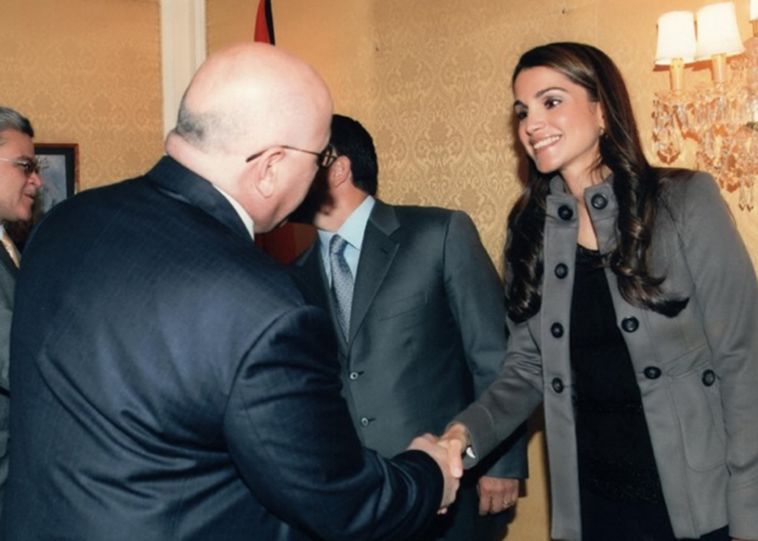
Reception with Her Majesty Queen Rania Al Abdullah of Jordan
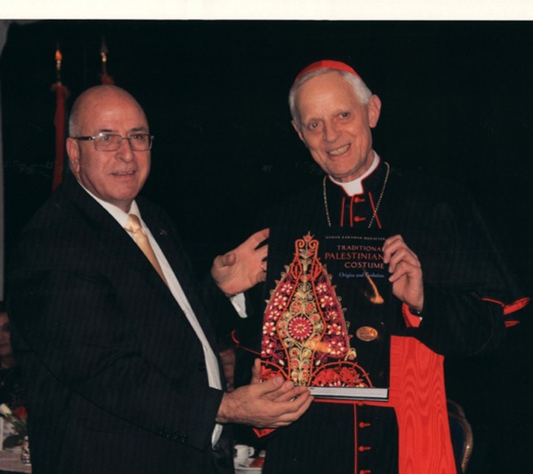
The Most Reverend Cardinal Donald W. Wuerl, Archbishop, Archdiocese of Washington (Formar)

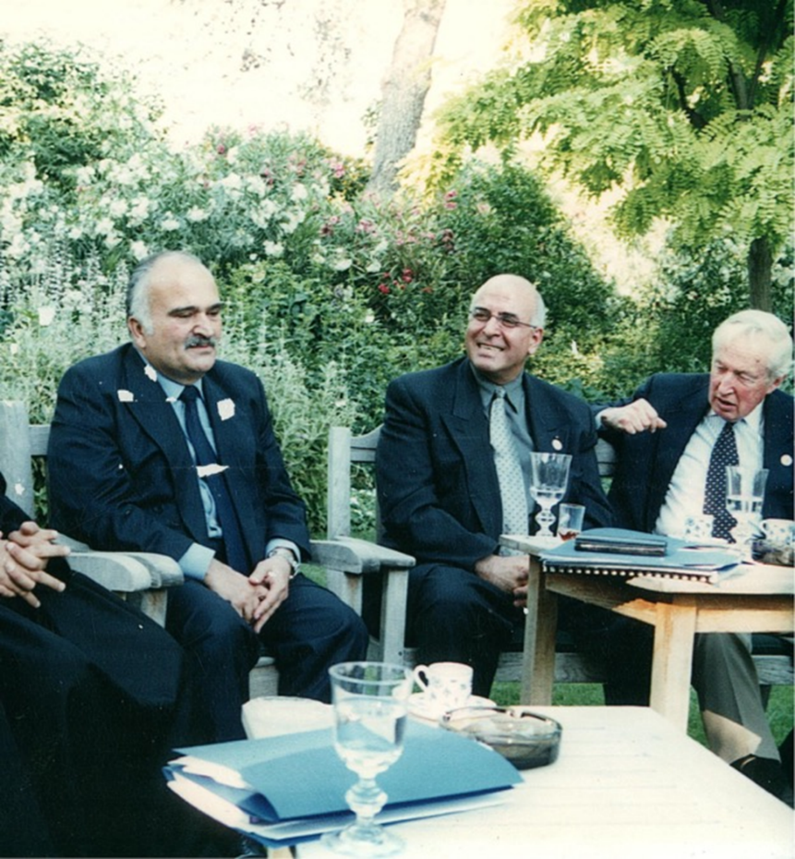
Conversation with His Highness Prince Hassan Bin Talal of Jordan
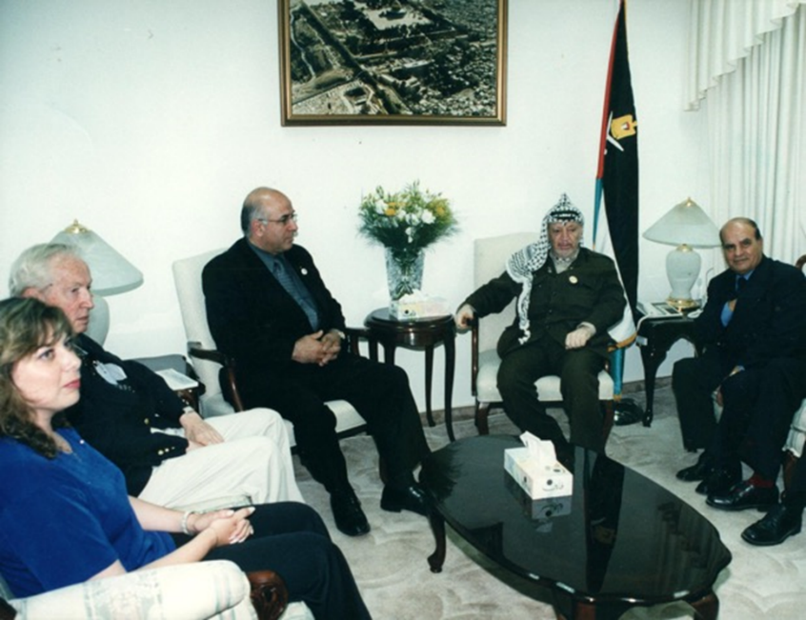
Official meeting with President Yasser Arafat of Palestine (Former)

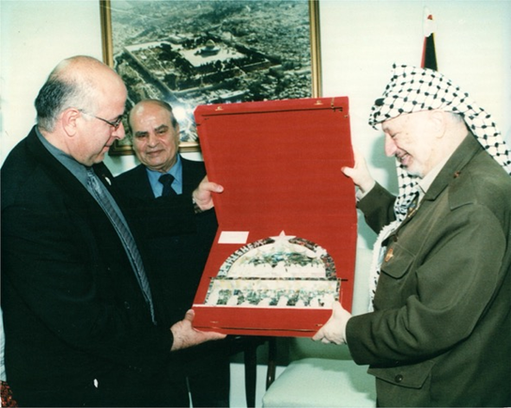
Presentation ceremony by President Yasser Arafat of Palestine (former)
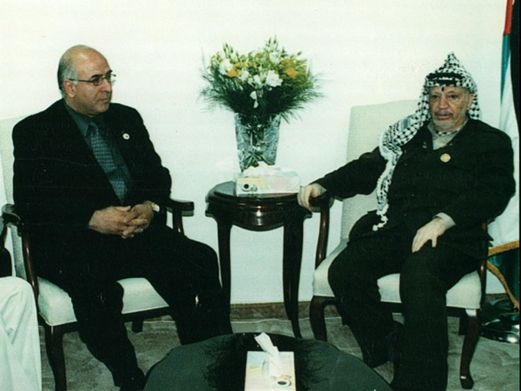
Presentation ceremony by President Yasser Arafat of Palestine (former)
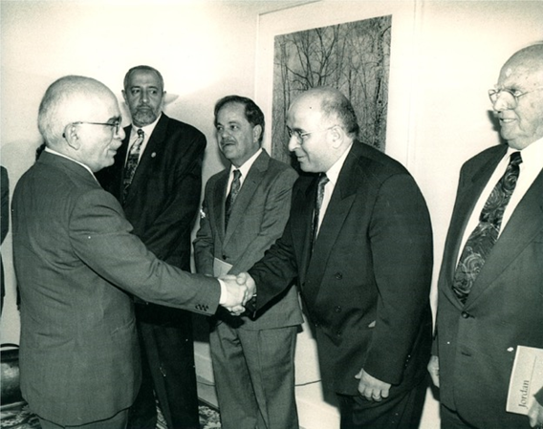
Reception with His Majesty King Hussein of Jordan (Former)
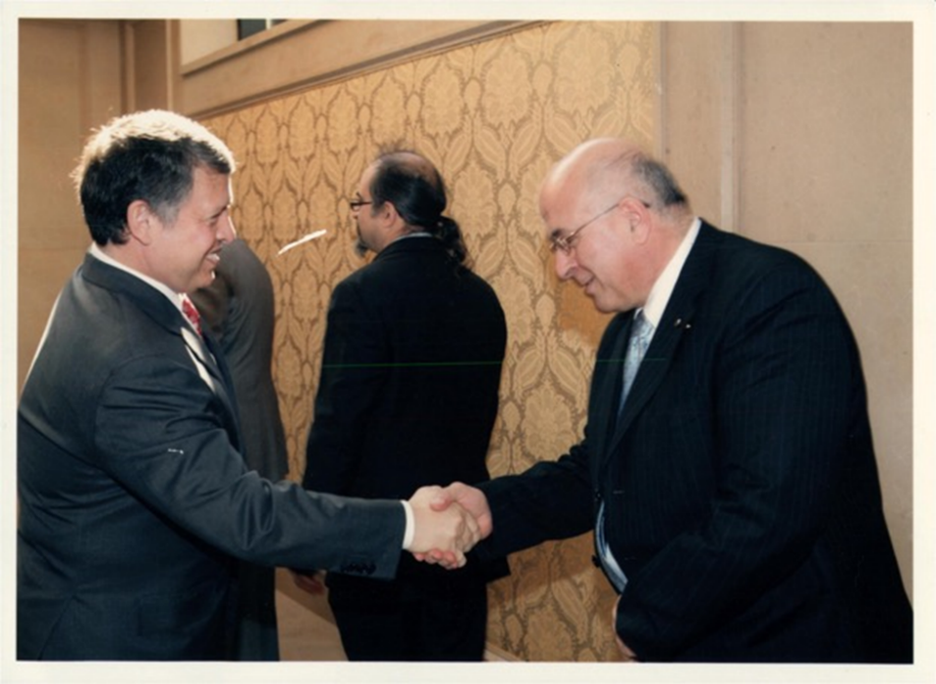
Reception with His Majesty King Abdullah II of Jordan

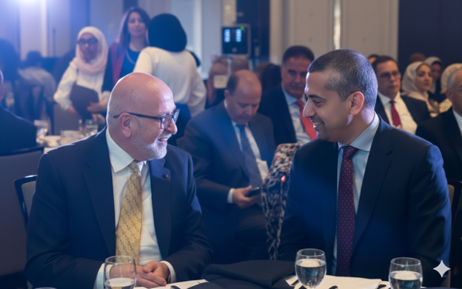

Banquet ceremony with distinguished guest Mr. Mehdi Hasan Broadcaster/Journalist,
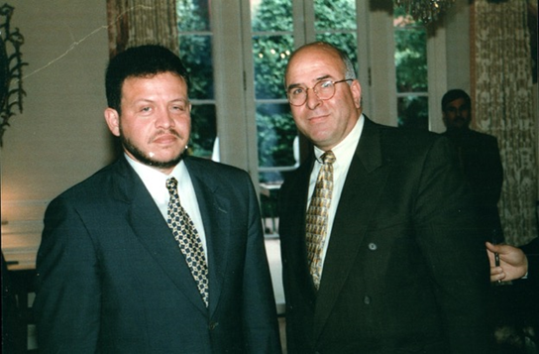
Reception with His Majesty King Abdullah II of Jordan

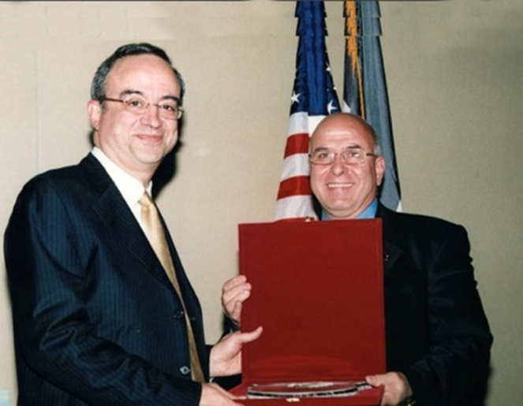
Award presentation to the former Deputy Prime Minister of Jordan, Dr. Marwan Muasher (Former)
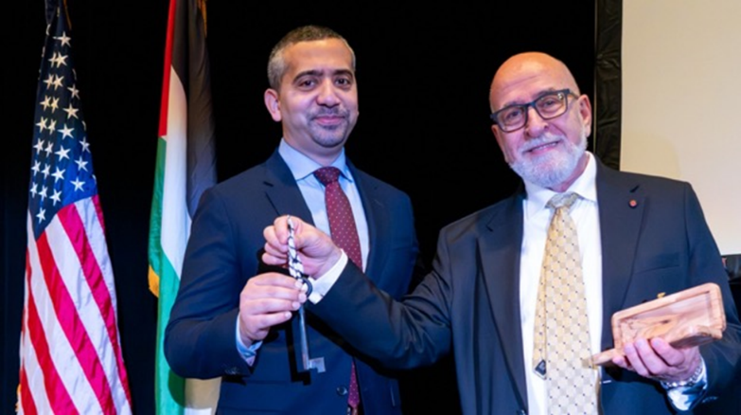
Honoring Mr. Mehdi Hasan Broadcaster/Journalist
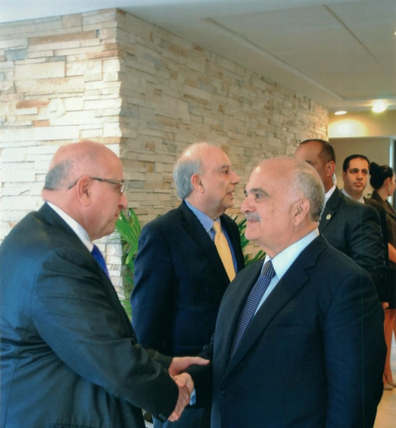
Reception with His Highness Prince Hassan Bin Talal of Jordan
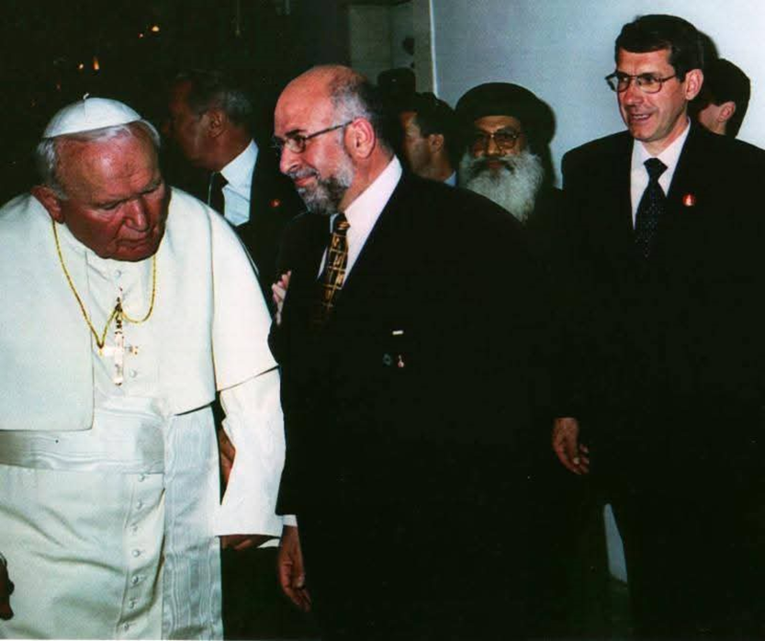
Meeting with His Holiness Saint Pope John Paul II in Jerusalem

